Name: ………………………………………………………...................................

Signature: …………………………………………
P525/3
CHEMISTRY
(PRACTICAL)
Paper 3
Jul/Aug. 2018
3 ¼ hours

INTERNAL MOCK EXAMINATIONS 2018

Uganda Advanced Certificate of Education

CHEMISTRY PRACTICAL

Paper 3

3 hours 15 minutes

INSTRUCTIONS TO CANDIDATES:

Answer ALL questions.
Record your answers on this question paper in the spaces provided.
Mathematical tables and silent non-programmable calculators may be used.
Reference books (i.e. text books, books on qualitative analysis, etc) should not be used.
Candidates are not allowed to start working with apparatus for the first 15 minutes. This time is to enable candidates to read the question paper and make sure they have all apparatus and chemicals that they may need.

(Fe = 56, S = 32, N = 14, H = 1, O = 16)
For Examiners’ Use Only
Q.1 | Q.2 | Q.3 | Total

1. You are provided with the following:
FA1, which is a solution containing sodium thiosulphate pentahydrate.
FA2, which is a solution containing 1.75g of potassium iodate, KIO₃, per 500cm³.
Solid R, which is a metal chromate, YCrO₄
2M sulphuric acid
10% potassium iodide solution
You are required to determine;
(a) The concentration of sodium thiosulphate in moll⁻¹
(b) The relative atomic mass of element Y in YCrO₄

Theory
In acidic solution, potassium iodate and potassium dichromate (VI) react with potassium iodine according to the following equations
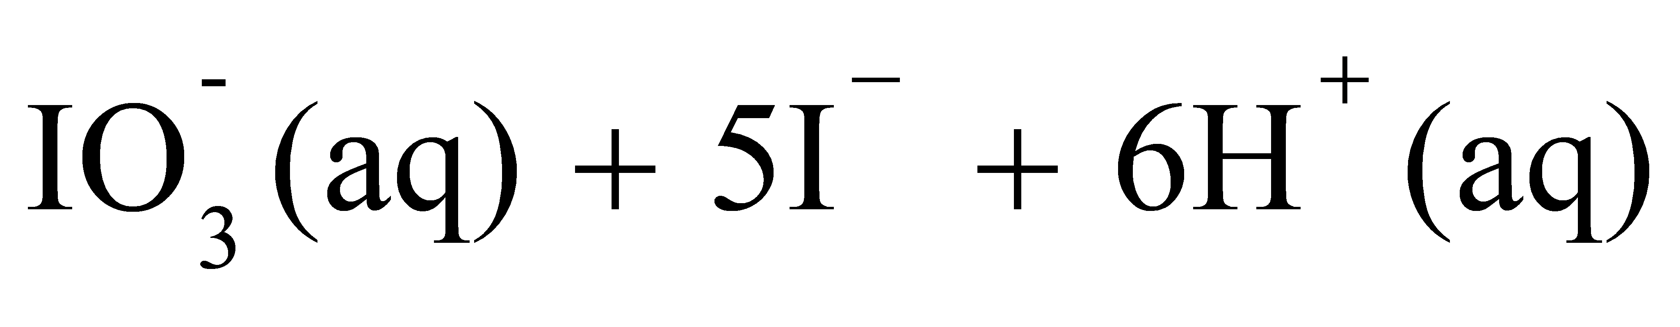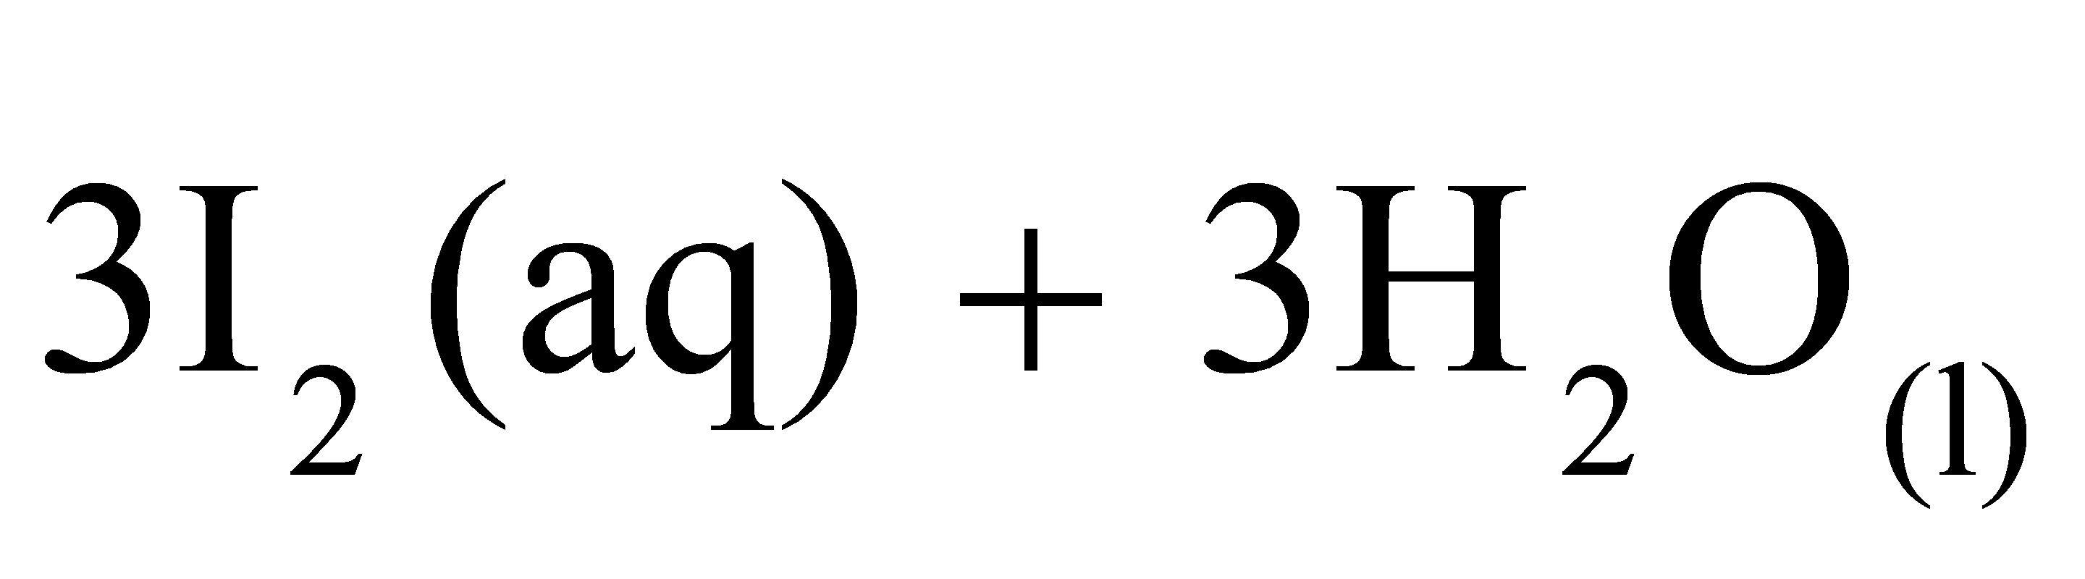
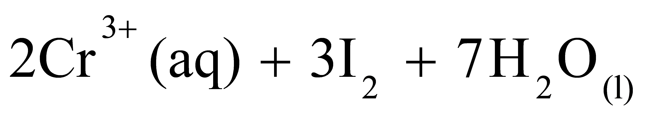

In acidic solution, the chromate ions are converted to the dichromate ions according to the equation.
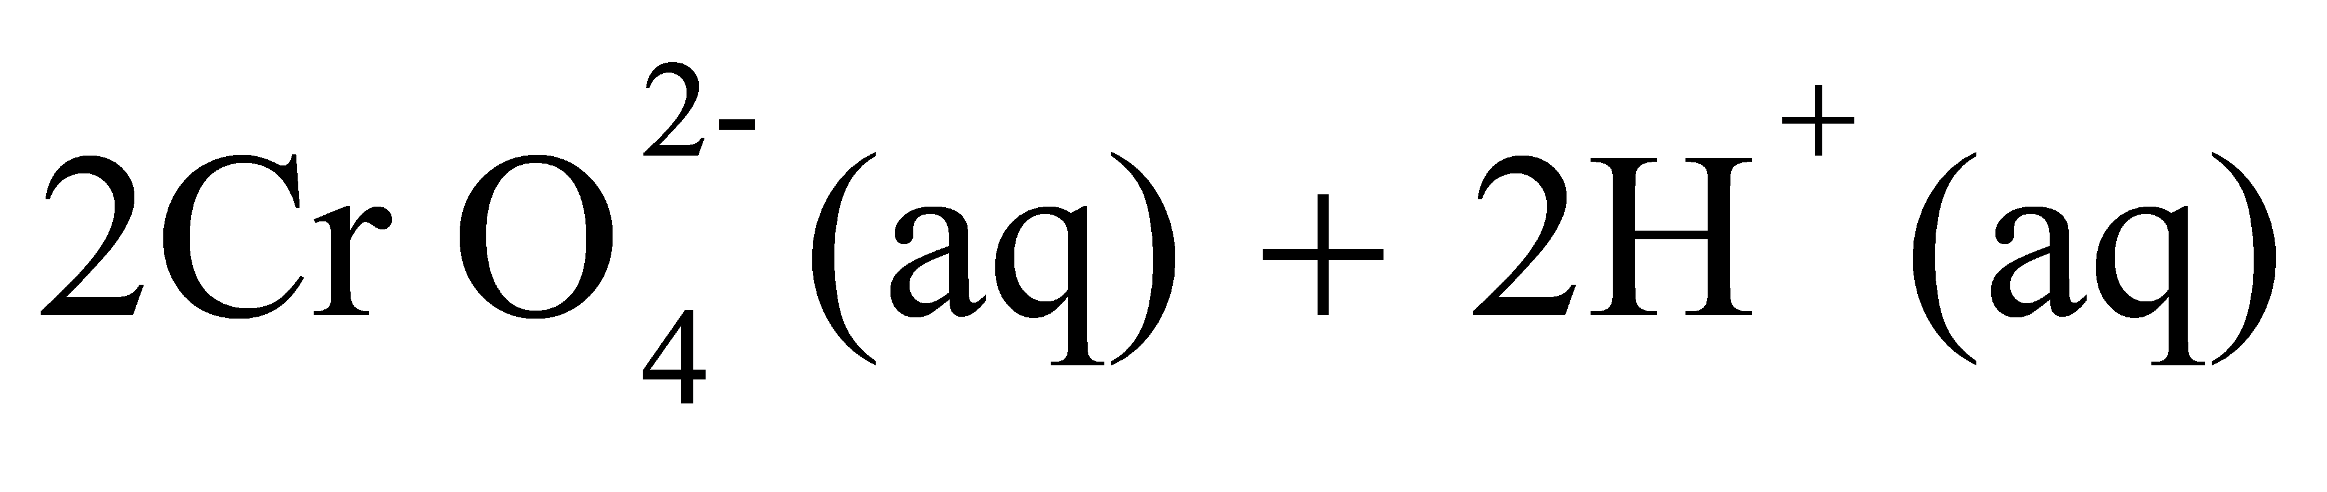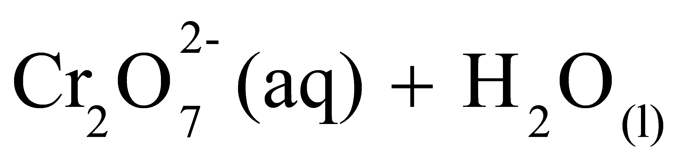

PART 1

Procedure:
Pipette 25cm³ (or 20cm³) of FA2 into a conical flask, add an equal volume of 2Msulphuric acid followed by 10cm³of 10% potassium iodine solution.
Titrate the liberated iodine with FA1 from the burette until the solution is pale yellow. Add 1 cm³ of starch indicator and continue the titration until the solution is colourless.
Repeat the titration 2 – 3 times until you obtain consistent results.
Record your results in the table below.

Volume of pipette used = ............................................................cm³

Final burette reading
Initial burette reading /cm³
Volume of FA1 used /cm³

Titre value used to calculate average volume of FA2............................, .........................

 Average volume of FA2 (V₁)
.................................................................................................................................
Questions:
(a) Calculate
(i) the number of moles of the iodate ions in 25cm³ of FA2.
(K = 39, I = 127, O = 16)

................................................................................................................................................................................................................................................................................................................................................................................................................................................................................................................................................................................................
(ii) the morality of the thiosulphate ions FA1
................................................................................................................................................................................................................................................................................................................................................................................................................................................................................................................................................................................................................................................................................................................................................................................................................................................................................................................................................................................................................................................
PART B
Weigh accurately about 1.4 g of R and transfer it to a 250cm³ volumetric flask. Add about 100cm³of distilled water to dissolve. Make to the mark with distilled water.
Label the solution FA3.
Pipette 25cm³ of FA3 into a conical flask, followed by an equal volume of 2 M sulphuric acid, then add 10cm³ of the potassium iodide solution and titrate the mixture with FA1 using starch as an indicator.
Repeat the titration 2 – 3 times until you obtain consistent results
Record your results in the table below
Results
Mass of beaker...........................................g
Mass of beaker and R ...............................g
Mass of R ................................................. g

Volume of pipette used ......................................cm³

Final burette reading
Initial burette reading /cm³
Volume of FA1 used /cm³

Titre values used to calculate average volume of FA1................................, .......................

 Average volume of FA1 used
..........................................................................................................................................
Questions:
(b) Calculate
(i) the number of moles of iodine liberated in 25cm³ of FA3
................................................................................................................................................................................................................................................................................................................................................................................................................................................................................................................................................................................................................................................................................................................................................
(ii) the number of moles of chromate ions, CrO₄²⁻ in 250cm³ FA3
................................................................................................................................................................................................................................................................................................................................................................................................................................................
(c) Determine the value of Y in YCrO₄
(Cr = 52, O = 16)

………………………………………………………………………………………………………………………………………………………………………………………………………………………………………………………………………………………………………………………………………………………………………………………………………………………………………………………………………………………………………………………………………………………………………………………………
2. You are provided with substance X which contains two cations and two anions. You are required to identify the cations and anions in X. Carry out the tests below and record your observations and deductions in the table below. Where a gas is evolved, it should be identified.

TESTS | OBSERVATIONS | DEDUCTIONS
- Heat one spatula end full of X strongly in a test tube.

- Transfer two spatula ends – full of X to a test tube. Shake strongly with about 4 cm³ of water and filter. Keep both the filtrate and the residue.

- Divide the filtrate into six portions.
- To the first portion add dilute ammonia solution Drop wise until in excess.

- To the second portion add dilute sodium hydroxide dropwise until in excess.
- Use the third portion, to carry out a test to confirm one of the cations in X.

- To the fourth portion add 1 cm³ of acidified potassium permanganate solution. Heat the mixture.

- To the fifth portion add 1 cm³ of dilute hydrochloric acid and warm the mixture.

- Use the sixth portion to confirm one of the anions in X.
- Wash the residue, dissolve it in dilute hydrochloric acid. Divide the resultant solution into three portions.

- To the first portion add dilute sodium hydroxide dropwise until in excess.
- To the second portion add dilute ammonia solution dropwise until in excess

- To the third portion add 3-4 drop of potassium chromate solution

(e) Identify (i) Cations in X ........................... and ....................................

(ii) Anions in X .......................... and .................................

- You are provided with an organic substance Y. Carry out the following tests and record your observations and deductions in the table below;

TEST | OBSERVATION | DEDUCTION
Burn a little of Y on a spatula.
Add 1 cm³ of Y to 1cm³ of water in a test tube and shake. Test the mixture with litmus, Add 2- 3 drops of sodium carbonate solution

Add 2 –3 drops of Y to 2 cm³ of Brady’s reagent
Add 3 drops of Y to 2cm³ of iodine solution . Add NaOH(aq) dropwise until the colour of iodine is discharged.
Add 2 cm³ of K₂Cr₂O₇/H⁺ to 3 cm³ of Y in a boiling tube heat the mixture. Divide the solution into two parts
To the first part add 3 drops of Brady’s reagent
To the second part add 3 drops of sodium carbonate solution

Describe the nature of Y:
………………………………………………………………………………………………………………………………………………………………………………………………………………

END

